**Name: ________________________________**

# Python Activity 7: Nested IF-ELSE Statements

|  |
| --- |
| **Learning Objectives**  Students will be able to:  *Content:*   * Explain the purpose of a nested if-else statement * Explain how to use Python if-elif structure * Explain how to test code using Python if-elif structure   *Process:*   * Write code that includes if-elif statement   **Prior Knowledge**   * Python concepts from Activities 1-6 |

**Critical Thinking Questions:**

1. Closely examine the flowchart and Python program above.

|  |
| --- |
| **Python Program** |

* 1. In the Python code, circle the if/else statement that is **nested** within another if/else statement.

if grade >=60

print("Satisfactory.")

else:

print("Poor")

* 1. Enter and test the code. List five numbers to test different parts of this program. Indicate what part of the program the number is testing.

|  |  |
| --- | --- |
| **Number** | **Part Tested** |
| 67 | Is your grade greater than or equal to 60 |
| 99 | Is your grade greater than or equal to 90 |
| 59 | Is your grade lower than 60 |
| 101 | Is your grade greater than or equal to 90 |
| -100 | Is your grade lower than 60 |

1. Enter and execute the following Python program using the same data as you used for #1b.

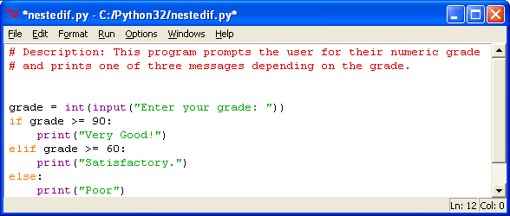

* 1. How does the output for this program compare with the output for the previous program?

This program acts identical but Is shorter and easier,

* 1. What new **keyword** is used in this program? elif which combines else and if.
  2. Notice the syntax of this program compared to the previous program. Which program contains simpler indentation? The second one

|  |
| --- |
| **FYI: elif** is the Python keyword that represents **else if** and allows you to test for one of several options**.** As soon as one of the tests is true, the rest are ignored. |

* 1. You can use **elif** as many times as you need to. Suppose you wanted to add the comment “Good!” for grades that are between 80 and 89. Where would you add it? Write the code for this additional choice.

grade = int(input("Enter your grade: "))

if grade >= 90:

print("very Good!")

elif grade >=80:

print("Good!")

elif grade >=60:

print("Satisfactory.")

else:

print("Poor")

* 1. Does it make a difference where the additional **elif** clause is placed? Mechanically no. length of the code wise yes.
  2. When is the code associated with the **else** statement executed?

When the input doesn’t meet any of the if or elif criteria

g. Change the program so that it prints the following messages. Write the code for the revised program below.

|  |  |
| --- | --- |
| Greater than 90 | “Very Good!” |
| Between 80 and 89 | “Good!” |
| Between 70 and 79 | “Satisfactory” |
| Between 60 and 69” | “Fair” |
| Less than 60 | “Poor” |

grade = int(input("Enter your grade: "))

if grade >= 90:

print("very Good!")

elif grade >=80:

print("Good!")

elif grade >=70:

print("Satisfactory")

elif grade >=60:

print("fair")

elif grade < 60:

print("Poor")

h. Make a final change to the program so that it prints an error message if the grade entered is greater than 100 or less than 0. Write the additional code below and draw a line to the program above to indicate where you would place this code.

grade = int(input("Enter your grade: "))

if grade > 100:

print("Error")

elif grade < 0:

print("Error")

elif grade >= 90:

print("very Good!")

elif grade >=80:

print("Good!")

elif grade >=70:

print("Satisfactory")

elif grade >=60:

print("fair")

elif grade < 60:

print("Poor")

1. Is the use of the **else** statement mandatory when creating an **if/elif** statement? Provide an example to support your answer.

No, it isn’t. In my code above the elif statement is the else. This else just also has a condition instead of being the consequence of not meeting that condition.

**Application Questions: Use the Python Interpreter to check your work**

1. Write an if/elif statement that assigns a value to the variable **bonus** depending on the amount of sales. Assume the amount of the sales is stored in a variable called **sales.**

|  |  |
| --- | --- |
| **Sales** | **Bonus** |
| >= 100,000 | 10,000 |
| >= 75,000 | 5,000 |
| >= 50,000 | 2,500 |
| >= 25,000 | 1,000 |

sales = int(input("Enter your sales numbers: "))

if sales >= 100000:

print("Your bonus will be $10,000!")

elif sales >= 75000:

print("Your bonus will be $5,000!")

elif sales >= 50000:

print("Your bonus will be $2,500!")

elif sales >=25000:

print("Your bonus will be $1,000!")